CHAINES SIMPLES DOUBLES TRIPLES AUX NORMES ISO
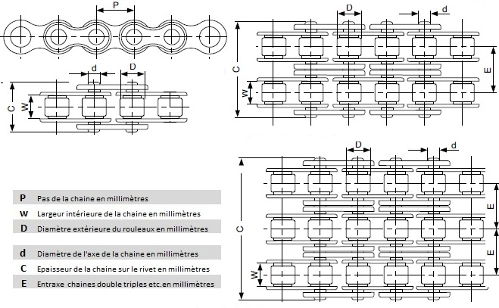
 | Ref. CODEX | Réf: ISO | P | W | ø D | ø d | C1 | C2 | C3
 | 04-B1-NI | 04B1 | 6 | 2,80 | 4,00 | 1,85 | 8,30
 | 05-B1-NI | 05B1 | 8 | 3,00 | 5,00 | 2,31 | 8,20
 | 06-B1-NI | 06B1 | 9,525 | 5,72 | 6,35 | 3,28 | 13,15
 | 08-B1-NI | 08 B1 | 12,7 | 7,75 | 8,51 | 4,45 | 17,50
 | 10-B1-NI | 10 B1 | 15,8 | 9,65 | 10,16 | 5,08 | 19,50
 | 12-B1-NI | 12 B1 | 19,050 | 11,68 | 12,07 | 5,72 | 22,50
 | 16-B1-NI | 16 B1 | 25,4 | 17,02 | 15,88 | 8,28 | 36,10
 | 20-B1-NI | 20 B1 | 31,75 | 19,56 | 19,05 | 10,19 | 41,30
 | 24-B1-NI | 24 B1 | 38,1 | 25,40 | 25,40 | 14,63 | 53,40
 | 28-B1-NI | 28 B1 | 44,45 | 30,99 | 27,94 | 15,90 | 65,10
 | 32-B1-NI | 32 B1 | 50,800 | 30,99 | 29,21 | 17,81 | 66,00
 | 06-B2-NI | 06 B2-NI | 9,53 | 5,72 | 6,35 | 3,28 | 23,40
 | 08-B2-NI | 08 B2-NI | 12,70 | 7,75 | 8,51 | 4,45 | 31,20
 | 10-B2-NI | 10 B2-NI | 15,88 | 9,65 | 10,16 | 5,08 | 36,10
 | 12-B2-NI | 12 B2-NI | 19,05 | 11,68 | 12,07 | 5,72 | 42,00
 | 16-B2-NI | 16 B2-NI | 25,40 | 17,02 | 15,88 | 8,28 | 68,00
 | 20-B2-NI | 20 B2-NI | 31,75 | 19,05 | 19,05 | 10,19 | 77,80
 | 24-B2-NI | 24 B2-NI | 38,10 | 25,40 | 25,40 | 14,63 | 101,70
 | 28-B2-NI | 28 B2-NI | 44,45 | 30,99 | 27,94 | 15,90 | 124,60
 | 32-B2-NI | 32 B2-NI | 50,80 | 30,99 | 29,21 | 17,81 | 124,60

